

St. Louis Public Schools’ Virtual School courses will be offered from grades K-12. The Virtual Learning Program is a part of the pioneering effort in the St. Louis Public Schools to address the needs of all children anytime, anywhere, at any pace.

A ***“virtual school”*** is defined as an education organiztion that offers K-12 courses through Internet or Web-based methods. Virtual K-12 is a form of distance education

Distance Education might be define as ***“formal education”*** in which instruction occurs while the teacher and learner are separate. The instructor led online courses will be mointor by Missour certified teachers using Missouri aligned curriculim



**Administrators**

Dr. Kevin Adams, Superintendent of Schools

Dr. Michael Brown, Deputy Superintendent

Mr. Charlie Bean, Program Supervisor

* Charlie.bean@slps.org
* (314) 345-4424

Ms. Wanda Garner, Program Counselor

* Wanda.garner@slps.org
* (314) 345-4470

**Virtual Learning Program Sites**

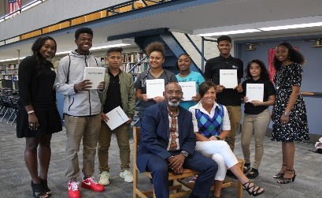

**Gateway Center**

* Sharon Berghoefer – Facilitator
* (314) 345-6963

**Roosevelt Center**

* Antionette Pabon - Facilitator
* (314) 345-6961

**Sumner Center**

* Carolyn McCray - Facilitator
* (314) 345-6962

**Vashon Center**

* Shelia Young - Facilitator
* (314) 345-6964



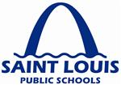

**VIRTUAL LEARNING PROGRAM**



**Creating the First and Best Choice**

**in Urban Education**

*Virtual learning is a computer based alternative to a traditional classroom experience. Students are delivered their education via web-based instruction with the same excellence in education delivered in all our SLPS Schools.*

***The Virtual Learning provides services for students K-12***

**St. Louis Public Schools**

**801 North 11th Street**

**St. Louis, MO 63101**

(314) 231-3720



WELCOME! The **Office of Student Recruitment and Placement**looks forward to assisting families interested in attending a St. Louis Magnet, Choice or Neighborhood school. For additional information regarding the enrollment process, please call 314-633-5200.

**Who Can Attend the SLPS Virtual Schools?**

* **Must be a St. Louis City Resident**
* **St. Louis Public School students**
* **Students in grade K-12**

**What is needed for enrollment?**

* **Proof of residency**
* **Birth Certificate**
* **Medical Records**
* **Report Card/Transcript**
* **Discipline Report**
* **Attendance Report**

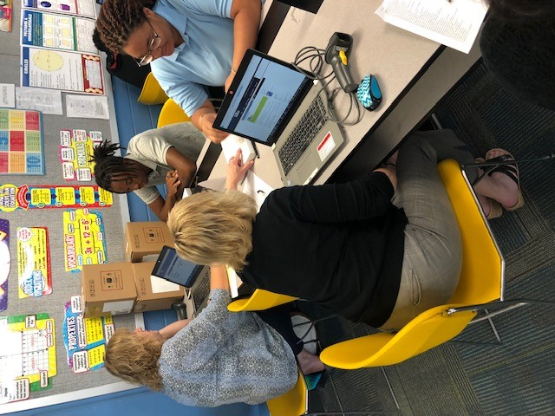



**First Semester – August thru November**

**Second Semester – January thru April**

**Mondays & Wednesday**

**8:00am – 3:00pm**

**Lunch 12-1pm**

**Tuesday & Thursday**

**12:00pm – 3:00pm**

**Fridays by appointments only**



**Monday-Friday**

**Full Time Students**

**8:00am-2:30pm**

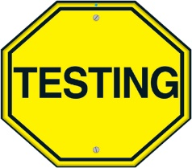

**All students enroll in the virtual learning program will take the require testing.**

**Grade 9th**

**STAR Testing – Aug/Sept**

**12th Graders**

**ACT/ASVAB/Accuplacer - Dec-April**

**Grade K-8th**

**Map Test**

**Grade 9th -12th**

**EOC Test – April/May**

**11th Graders**

**ACT – April**

**Grade 9th -12th**

**WIDA (ELLS) – Second Semester**

